Title in Englisch (style: 18pt, Times New Roman, after: 24)
Name Surname, Name Surname, (Style: Name, TNR, 14pt., after 12)
Abstract: Abstract (maximum 10 lines) in English, (style: abstract, 10pt, space after: 6). Double-sided indention of 1 cm should be used in the whole summary, justified text. Abstract (maximum 10 lines) in English, (style: abstract, 9pt, space after: 6pt). Double-sided indention of 1 cm should be used in the whole summary, justified text.
Keywords: Word, Word, Word (style: abstract, 10pt, space after: 6pt).

Introduction
It is important that introduction contains description of article subject with highlighted some new elements of research.
Text of your paper (full version) is written in English language (Times New Roman 10, style: Normal). Text must be justified. The 0.5 cm indent should be applied for the first line in second section. Page is centre, all margins should be 2.5 cm. Number of pages is 4 - 6.

Chapter 1 (style: 1. Subtitle, TNR, 14pt, space before:18, after 12)
Text of your paper (full version) is in English language (Times New Roman 10, style: Normal). Text must be justified. The 0.5 cm indent should be applied for the first line in second section. Number of pages is STRICTLY not more than 6!!!

Subchapter (style: 2. Subtitle, TNR, 13pt, space before:12, after 12)
Text of your paper (full version) is written in English language (Times New Roman 10, style: Normal). Text must be justified. The 0.5 cm indent should be applied for the first line in second section. Number of pages is STRICTLY not more than 6!!!
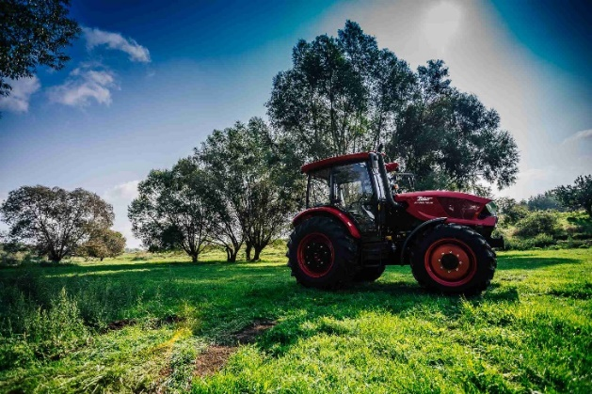
Fig. 1 Figure description (style: Figure, 10pt, space after: 12pt, before: 12)
Drawings and graphs, prepared with the help of any method or technique, should be the integral part of the text. Tables and figures should be consecutively numbered. Figure captions and table titles must be centered, without a dot at the end and in the article language. Place table titles above the tables and align to center and figure captions below the figures.
Tab. 1 Table description (style: Figure, 10pt, space before: 12, after: 12)
 | xxx | xxx
a | 5.48 | 2.1
b | 9.35 | 5.4
All equations must be set or clearly type and consecutively numbered. Refer to equations in the text as Eq. (1), Eq. (2). The 0.5 cm indent should be applied for the equations. Displayed equations should be numbered simply as (1), (2), (3). The numbers should appear at the extreme right of the line in parentheses.

1
(style: Equations, 10pt, space before: 6pt, after: 6pt)
Text of your paper (full version) is written in English language (Times New Roman 10, style: Normal). Text must be justified. The 0.5 cm indent should be applied for the first line, second section. Number of pages is STRICTLY not more than 6!!!

2

Subchapter (style: 2. Subtitle, TNR, 13pt, space before:12, after 12)
Text of your paper (full version) is written in English language (Times New Roman 10, style: Normal). Text must be justified. The 0.5 cm indent should be applied for the first line in second section. Number of pages is STRICTLY not more than 6!!!
- Text of your paper (full version) is written in English language.
- Text of your paper (full version) is written in English language.
- Text of your paper (full version) is written in English language.
- Text of your paper (full version) is written in English language.
- Text of your paper (full version) is written in English language.
- Text of your paper (full version) is written in English language.
- Text of your paper (full version) is written in English language.
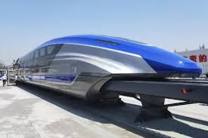
Fig. 2 Figure description (style: Figure, 10pt, space after: 12pt, before: 12)

Subchapter (style: 3. Subtitle, TNR, 12pt, space before:12, after 12)

3

Subchapter (style: 3. Subtitle, TNR, 12pt, space before:12, after 12)

4

5

Conclusion
Text of your paper (full version) is written in English language (Times New Roman 10, style: Normal). Text must be justified. The 0.5 cm indent should be applied for the first line in second section. Number of pages is STRICTLY not more than 6!!!

Acknowledgement
Text of your paper (full version) is written in English language (Times New Roman 10, style: Normal). Text must be justified. The 0.5 cm indent should be applied for the first line in second section. Number of pages is STRICTLY not more than 6!!!

References
- UIC 518: Testing and approval of railway vehicles from the point of view of their dynamic behaviour - Safety - Track fatigue - Ride quality. 4-2009. (style: References, TNR, 10pt)
- Chudzikiewicz A., Melnik R.: Statistical Analysis of Vibration for the Rail Vehicle Suspension Monitoring System. 13th MINI Conference on Vehicle System Dynamics, Identification and Anomalies, Budapest, Hungary 5-7 November, 2012. In edit.
- Melnik R., Sowiński B.: Application of the Rail Vehicle’s Monitoring System in the Process of Suspension Condition Assessment. Communications- Scientific Letters of the University of Zilina, vol. 15, No. 4, 2013, pp. 3-8 (in print), ISSN 1335-4205.

Name Surname, titles, Warsaw University of Technology, Faculty of Transport, Department of Vehicle Maintenance and Operation, ul. Koszykowa 75, 00-662 Warsaw, tel.: , e-mail: n.s@wt.pw.edu.pl,
Name Surname, titles, tel.: , e-mail: n.s@wt.pw.edu.pl,
Name Surname, titles, tel.: , e-mail: n.s@wt.pw.edu.pl. (Style: Authors, TNR, 10pt)

